Table Of Contents

Contents

1. **SLA Measurement** 3

* **Measurement Attributes** 3
* **Ticket progression -** 4
* **SLA Measurement Example -** 5

1. **Pausing of SLA measurement** 6

* **How to Pause Ticket** 6
* **Steps to Pause Ticket SLA** 7

1. **SLA plan correction** 8

* **How to Correct SLA Plan** 8
* **Example of SLA correction** 9

1. **SLA manual Status Correction** 10

* **Example of SLA Manual Correction** 11

1. **SLA Reporting** 11

* **Search Metrics** 12
* **Steps To generate reports** 12
* **Combine Reports** 18

1. Test Cases 20

* As a support agent, provide each SLA status on time 20
* As a support agent, provide each SLA status after their set time has expired 20
* As a support agent, miss First Response SLA and provide the rest of SLA statuses on time 20
* As a support agent, miss Temporary Solution SLA and provide the rest of SLA statuses on time 21
* As a support agent, miss Final Solution SLA and provide the rest of SLA statuses on time 21
* As a support agent, achieve all three SLA statuses, and then edit ticket’s SLA plan to recalculate missed SLA statuses 21
* As a support agent, miss all three SLA statuses, and then edit ticket’s SLA plan to recalculate missed SLA statuses 22
* Pause and resume Temporary Solution SLA time calculation 22
* Pause and resume Final Solution SLA time calculation 23
* As a support agent, manually update desired missed SLA status to achieved status 24
* As a support agent, manually export closed tickets with their respective SLA plans and statuses to CSV file 24

# **SLA Measurement**

To Understand SLA Measurement, we need to understand basic flow and below points.  
We already created **SLA Plan and configured its instances in plugin.**  
We have 3 timeframes for agent to complete the assigned task with selected SLA Plan.

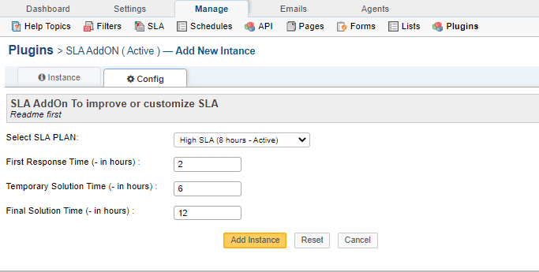

**Measurement Attributes  
  
First Response Time-**  ( In Hours)

1. First updates on ticket by agent is refer as first response time i.e. Acknowledgment that Agent is working on a ticket.
2. First Response should be within a time frame set by SLA, for example, we have 8 hours to respond when we are working on a low priority ticket. If response provided within assigned timeframe then status will be Achieved else status set to Missed . You can see this in ticket view page from agent Login.
3. To let them know if we need more information, based on selected SLA Plan then agent set **Awaiting response** status for ticket and it also consider as first response time. When user response then ticket will again open.

**Temporary Solution Time -** ( In Hours)

1. After providing a confirmation that we are working on a ticket (First response) we have a timeframe to provide a Temporary solution. We created a new status type named as “Temporary solution”.
2. Temporary Response should be within a time frame set by SLA for Temporary Response. If response provided within assigned timeframe then status will be Achieved else status set to Missed.

**Final Solution -** ( In Hours )  If Temporary solution SLA is missed, Final solution SLA will start ticking from a moment when a Temporary solution expires. After all the conversation between agent and user , agent conclude the final solution for user and set status to final status which is **“closed”.**

1. **If agent will be able to close ticket in timeframe then** Final Solution Time **will be showing as Achieved** else **Missed.**

**Statuses  
  
Open** – Marks all the tickets that are either new or are worked on, SLA that needs to be measured in this status are First response SLA and from First response to Temporary solution SLA.   
  
**Temporary solution** – Ticket is still opens but serves as a mark for both when the Temporary solution SLA count stops and Final solution SLA count begins.

**Closed** – Stops all SLA, it also freezes any further SLA calculation and marking achieved or missed SLA.s

**Awaiting Response** – Pauses the SLA. Upon received answer it should automatically change to status Open.

**Ticket progression -**Ticket Created >> First Response >> Temporary Response >> Closed

**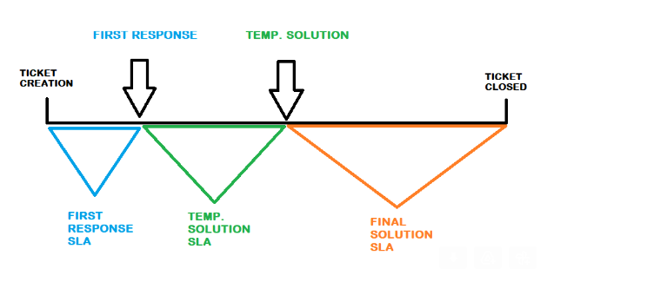****Basic Ticket Flow With Sla Addon:**

1. Ticket is created We provide a first response.  
   Agent Side – Then time when first response is provided either reply or await status. First Response Time will be recorded and as per timeline of first response status will be set.

Ticket Status = Open   
Ticket State = Open

1. Once Agent provides a temporary solution by changing status to temporary solution

Agent Side – Temporary response time will be recorded and then as per timeline of temporary solution, temporary response status will be set.

Ticket Status = Temporary solution provided  
 Ticket State = Open

1. After all communication between agent and user, Agent reaches to final status. Once we provide a final solution, we close a ticket.  
   So the closing time will be recorded as Final Response Time and then as per timeline of Final solution, Final response status will be set.

Ticket Status = Closed  
 Ticket State = Closed

**SLA Measurement Example -**SLA belonging to the **Low SLA**:

**First response time:** **4** hours – if the agent responds after one hour saying that the ticket has been well received and that we are working on it, the SLA for first response time would be achieved, if the first response time comes after more than 4 hours, it would be missed, and everything would be measured.

**Temporary solution:** **8** hours – Upon giving the first response,   
If the first response is missed then the temporary solution time starts to tick for 8 hours from first response expiration.  
if the first response is Achieved then the then temporary solution time starts to tick for 8 hours from First response Time achieved.  
 If no answer has been provided in this timeframe, the SLA for temporary solution would be missed. If an answer has been provided during this timeframe, the result would otherwise be achieved.

**Final solution:** **12** hours – Once a temporary solution has been given and status changed to "Temporary solution provided" the time for a final solution starts to tick,   
If the temporary response is missed then the final solution time starts to tick for 12 hours from Temporary solution expiration .  
if the temporary response is Achieved then the then final solution time starts to tick for 12 hours from Temporary Response Achieved Time .  
 if no answer is given within the time limit, then the SLA would be missed and if a final answer is given, then the result would be achieved.

# **Pausing of SLA measurement**

It will be managed by new status created **Awaiting response.**When user set ticket status to **Awaiting response the Sla** will be paused until next user Response.   
When Agent got user response SLA **will resume again** SLA will again start as per the selected schedule (example- 24/7 OR 24/5 etc.) associated with SLA Plan.  
In a case that ticket with an SLA plan that has coverage 24/7 changed status to open after a provided answer, SLA will start resume immediately.

**How to Pause Ticket**  
  
Go To agent panel and select status “Awaiting Response” and update ticket with note or query as you need.  
  
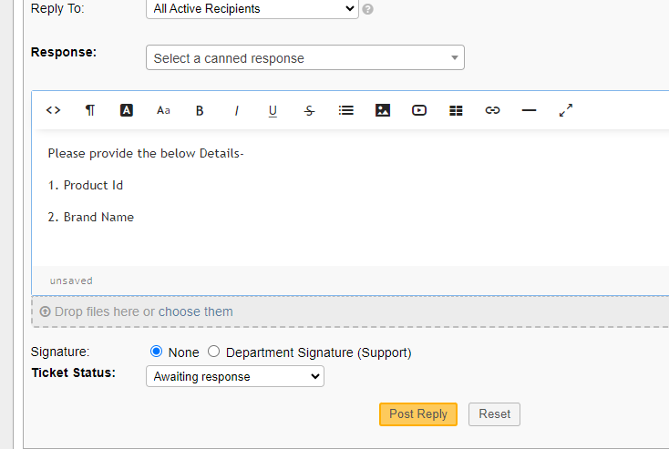

**Steps to Pause Ticket SLA**

* 1. Ticket created via email/manually. (Status – Open, State - Open)
  2. Response to ticket for more clarity. (Status – Awaited, State - Open)
  3. Once Response(reply) from user on ticket. (Status- Open, State - Open)
  4. Response from agent with temp solution (Status – Temp Solution, State - Open)
  5. After sometime agent response to the ticket with final solution (Status – Final Solution, Stat – Closed/Resolved)
  6. Due date will be updated accordingly as per the time.

# **SLA plan correction**

At any Point of time, If agent feel that the ticket is low and it should follow the low sla plan instead of High SLA plan . So, This feature help this functionality to make plan correction.  
  
User can change SLA plan manually and status will update accordingly.   
  
First Response Time, Temporary Solution Time and Final Solution time will not change, only status will update as per the new plan. It uses time on a ticket to “restamp” the tickets according to the newly selected SLA plan.  
  
It is also possible to update plan in between any status, ticket will process as per the new plan for next status.

**How to Correct SLA Plan**  
  
**Step 1- Go to agent Panel** and view ticket and then click on edit Ticket button .  
  
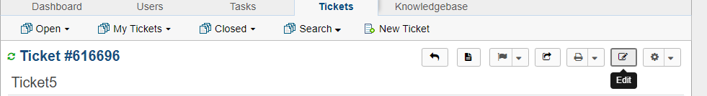

**Step 2 => update Sla plan**

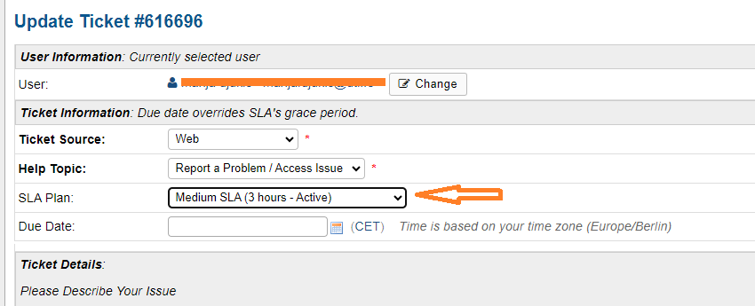

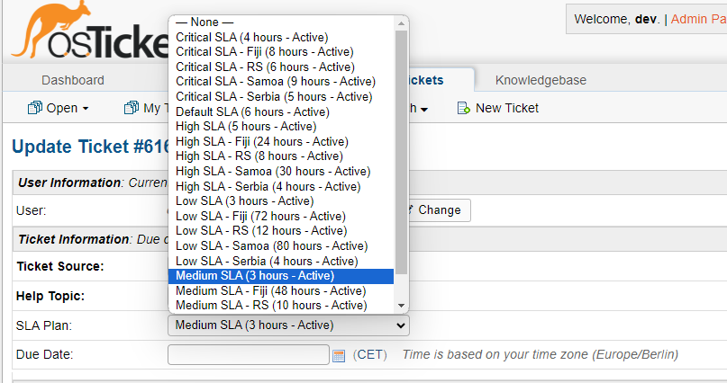

**Step 3 – then Save the ticket.**

**Example of SLA correction**

First Response - **miss** > Temporary solution- **achieved** > Final Solution- **miss**

Upon closure, it was noted that the issue was not critical, by changing SLA plan we need the OSTicket to recalculate the SLA, agent can put an internal note.

Per new calculation, OSTicket would leave a new note stating what was missed or achieved based on recalculation according to the newly set SLA plan.

First Response - **achieved** > Temporary solution - **achieved** > Final Solution - **achieved**

# **SLA manual Status Correction**

There is an option to manually correct SLA calculation. Such action should always be followed by who (which agent – similar or same to the way OSTicket does other stamping inside a ticket) committed such change with preferable mandatory internal note for whom ever changes the SLA calculation manually to be prompted to provide a reasoning.

There is anchor link available with all 3 status, on click of anchor links (Status) , a new dialog box will open and user can change status manually with mandatory reason.  
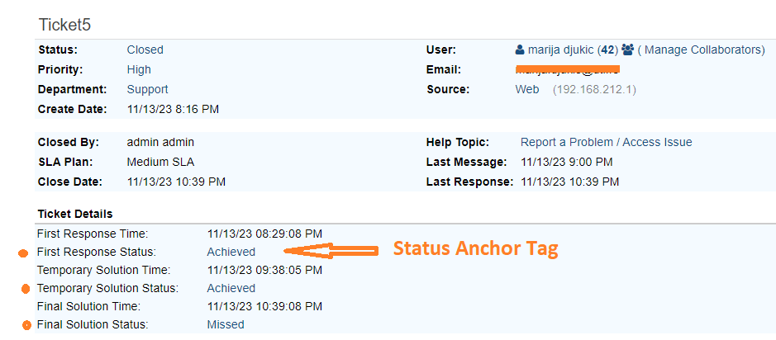

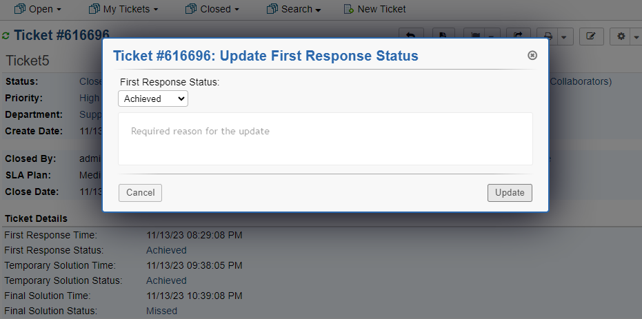

**Example of SLA Manual Correction**

Ticket was closed by mistake earlier than intended, marking the SLA as achieved.

First Response - **achieved** > Temporary solution - **achieved** > Final Solution - **achieved**

However, subsequently it was determined that the Final solution was not achieved in time to “catch” the SLA. Support Agent must manually change Final Solution to miss.

First Response - **achieved** > Temporary solution - **achieved** > Final Solution - **miss**

# **SLA Reporting**

By using Advanced Ticket Search function in OSTicket, we have options to search by 3 metrics for both SLA achieved and missed.  
Please see the below table for search combinations, you can have combine reports also, by using both fields in Advanced search .

**Search Metrics**

|  |  |  |  |
| --- | --- | --- | --- |
| Status | First Response Status | Temporary Response Status | Final Solution Status |
| Missed | x | x | x |
| Achieved | x | x | x |

|  |  |  |  |
| --- | --- | --- | --- |
| Date Ranges | First Response Time | Temporary Response Time | Final Solution Time |
|  | x | x | x |

## **Steps To generate reports**

**Step 1** **-** Go To Agent Panel and then go to ticket listing Page

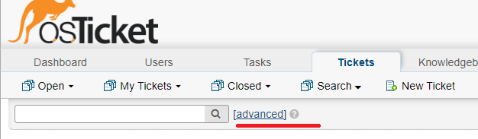  
**Step 2 –** Click on advanced Link , It will open a new window.  
  
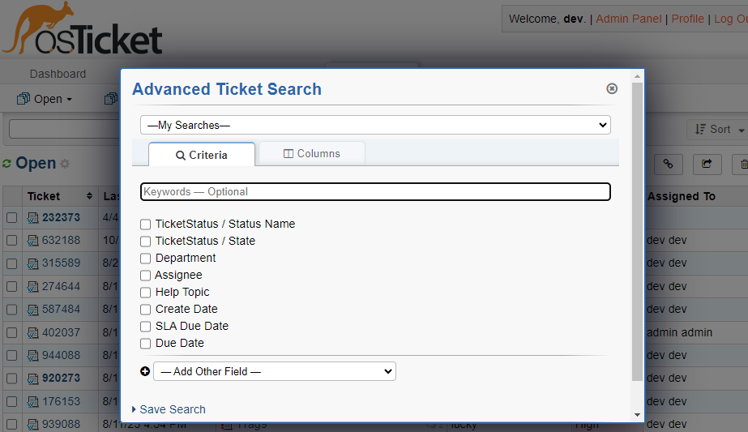

**Step 3 -** Click On “**Add other Field**” , A new dropdown will appear , here you can add fields .  
  
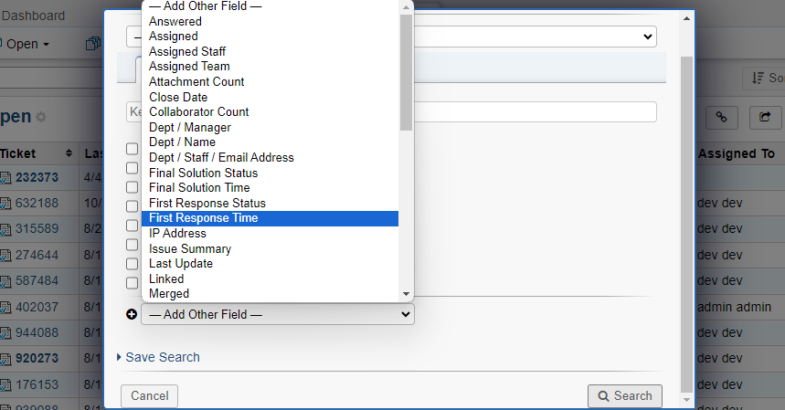

Step 3 – Suppose we need ticket who have first response status achieved. So,   
**1.** we select First Response Status from drop down. After that When you check Frist response status checkbox, a new dropdown will show and ask for operation , You have to choose operation as per your need.  
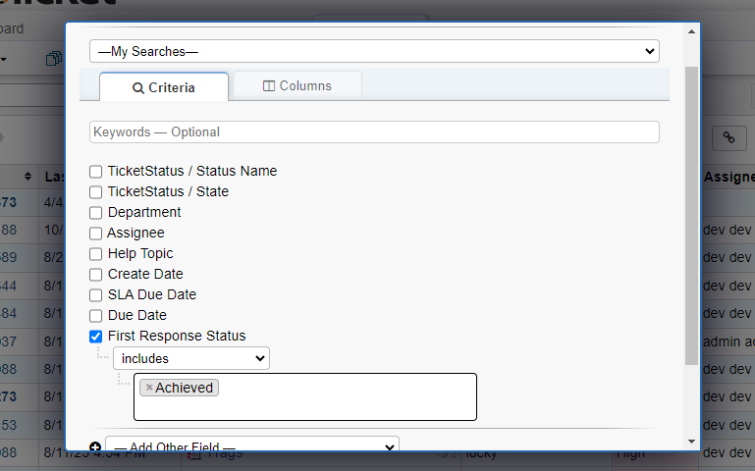

**2.** In this example we choose “includes”   
  
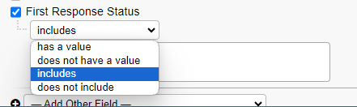  
 **3.** Now we can see 2 options (Achieved and Missed) in textbox. We can choose as we want. In Our case we select **Achieved**.

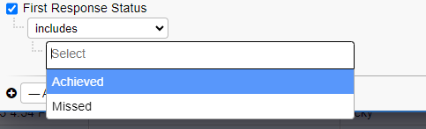

**4.**Then Click on search button  
  
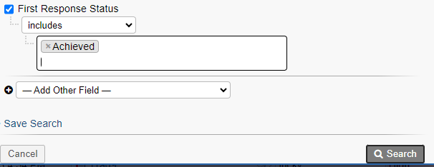  
  
  
5. Now you will see the List of Tickets , that have first response status is achieved .You can export the reports in excel format , by go to export option, You can see bottom of list   
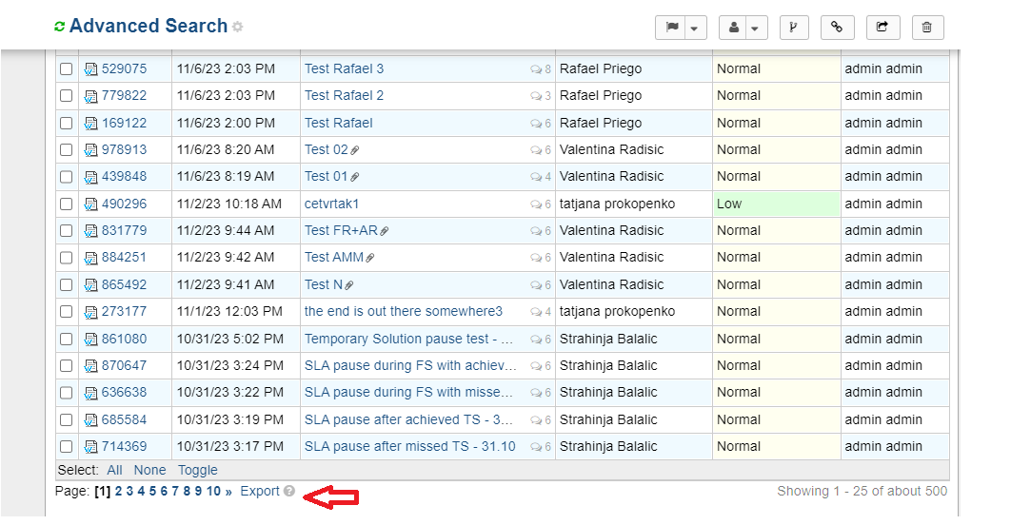  
  
Here is example for Export sheet  
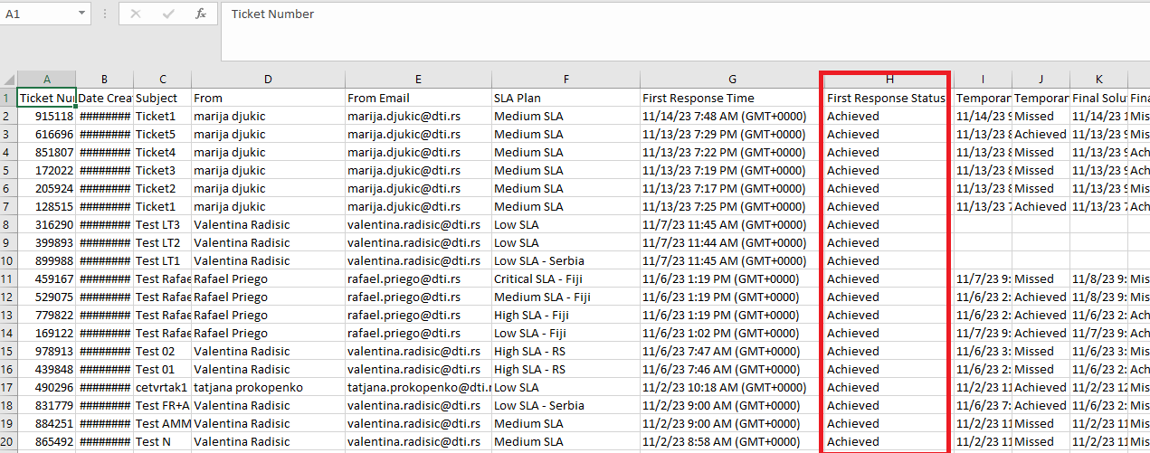  
  
In Same way you can generate any combination Reports.

**Combine Reports**   
  
  
Here you can select combination of fields for reports .  
  
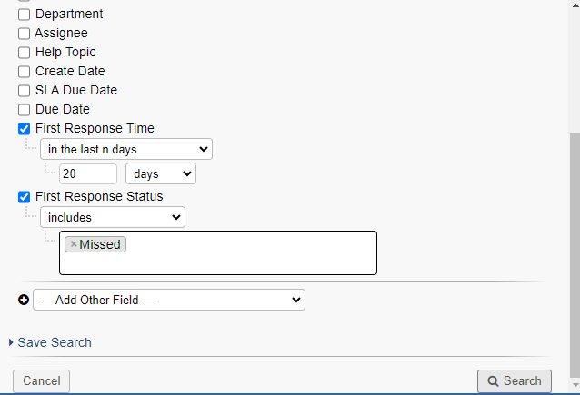  
  
Here you can again see list of filtered ticket and we can also export those list.  
Here We are exporting few fields for better understanding.  
  
Combine Exported Report   
  
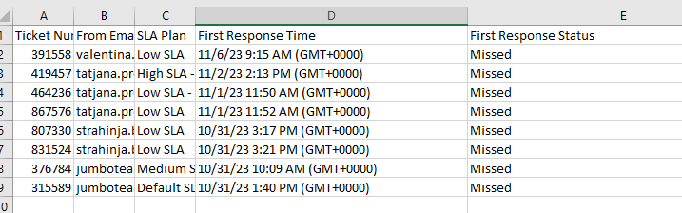

# Test Cases

## As a support agent, provide each SLA status on time

Prerequisite: Client needs to open a ticket

|  |  |  |
| --- | --- | --- |
| Steps | Action | Expected result |
| 1. | Provide First Response before configured First Response SLA time expires | First Response is achieved |
| 2. | Provide Temporary Solution before configured Temporary Solution SLA time expires | Temporary Solution is achieved |
| 3. | Provide Final Solution before configured Final Solution SLA expires | Final Solution is achieved |

## As a support agent, provide each SLA status after their set time has expired

Prerequisite: Client needs to open a ticket

|  |  |  |
| --- | --- | --- |
| Steps | Action | Expected result |
| 1. | Provide First Response after configured First Response SLA time expired | First Response is missed |
| 2. | Provide Temporary Solution after configured Temporary Solution SLA time expired | Temporary Solution is missed |
| 3. | Provide Final Solution after configured Final Solution SLA expired | Final Solution is missed |

## As a support agent, miss First Response SLA and provide the rest of SLA statuses on time

Prerequisite: Client needs to open a ticket

|  |  |  |
| --- | --- | --- |
| Steps | Action | Expected result |
| 1. | Provide First Response after configured First Response SLA time expired | First Response is missed |
| 2. | Provide Temporary Solution before configured Temporary Solution SLA time expires | Temporary Solution is achieved |
| 3. | Provide Final Solution before configured Final Solution SLA expires | Final Solution is achieved |

## As a support agent, miss Temporary Solution SLA and provide the rest of SLA statuses on time

Prerequisite: Client needs to open a ticket

|  |  |  |
| --- | --- | --- |
| Steps | Action | Expected result |
| 1. | Provide First Response before configured First Response SLA time expires | First Response is achieved |
| 2. | Provide Temporary Solution after configured Temporary Solution SLA time expired | Temporary Solution is missed |
| 3. | Provide Final Solution before configured Final Solution SLA expires | Final Solution is achieved |

## As a support agent, miss Final Solution SLA and provide the rest of SLA statuses on time

Prerequisite: Client needs to open a ticket

|  |  |  |
| --- | --- | --- |
| Steps | Action | Expected result |
| 1. | Provide First Response before configured First Response SLA time expires | First Response is achieved |
| 2. | Provide Temporary Solution before configured Temporary Solution SLA time expires | Temporary Solution is achieved |
| 3. | Provide Final Solution after configured Final Solution SLA expired | Final Solution is missed |

## As a support agent, achieve all three SLA statuses, and then edit ticket’s SLA plan to recalculate missed SLA statuses

Prerequisite: Client needs to open a ticket

|  |  |  |
| --- | --- | --- |
| Steps | Action | Expected result |
| 1. | Provide First Response before configured First Response SLA time expires | First Response is achieved |
| 2. | Provide Temporary Solution before configured Temporary Solution SLA time expires | Temporary Solution is achieved |
| 3. | Provide Final Solution before configured Final Solution SLA expires | Final Solution is achieved |
| 4. | Change SLA Plan by pressing “Edit” button, choose appropriate SLA plan, and then click “Save” button | All three SLA statuses are properly recalculated using new SLA plan configuration |

## As a support agent, miss all three SLA statuses, and then edit ticket’s SLA plan to recalculate missed SLA statuses

Prerequisite: Client needs to open a ticket

|  |  |  |
| --- | --- | --- |
| Steps | Action | Expected result |
| 1. | Provide First Response after configured First Response SLA time expired | First Response is missed |
| 2. | Provide Temporary Solution after configured Temporary Solution SLA time expired | Temporary Solution is missed |
| 3. | Provide Final Solution after configured Final Solution SLA expired | Final Solution is missed |
| 4. | Change SLA Plan by pressing “Edit” button, choose appropriate SLA plan, and then click “Save” button | All three SLA statuses are properly recalculated using new SLA plan configuration |

## Pause and resume Temporary Solution SLA time calculation

Prerequisite: Client needs to open a ticket

|  |  |  |
| --- | --- | --- |
| Steps | Action | Expected result |
| 1. | Provide First Response before configured First Response SLA time expires | First Response is achieved |
| 2. | Pause Temporary Solution SLA time by writing down the response for customer, and changing Ticket Status to “Awaiting Response” | Temporary Solution SLA time is no longer calculated or “ticking”. Ticket is changed to “Awaiting Response” status |
| 3. | As a customer, provide an answer to a ticket | Ticket is switched back to “Open” status. Temporary Solution SLA time is being calculated again. |
| 4. | As a support agent, provide Temporary Solution | Temporary Solution SLA time is recalculated together with the amount of paused time. If we had a pause of 10 minutes - those 10 minutes will not be deducted from configured Temporary Solution SLA time frame.  If Temporary Solution SLA time was originally 1 hour, and we had a pause of 10 minutes – new Temporary Solution SLA time will be 1 hour + 10 minutes. |
| 5. | Provide Final Solution before configured Final Solution SLA expires | Final Solution is achieved |

## Pause and resume Final Solution SLA time calculation

Prerequisite: Client needs to open a ticket

|  |  |  |
| --- | --- | --- |
| Steps | Action | Expected result |
| 1. | Provide First Response before configured First Response SLA time expires | First Response is achieved |
| 2. | Provide Temporary Solution before configured Temporary Solution SLA expires | Temporary Solution is achieved |
| 3. | Pause Final Solution SLA time by writing down the response for customer, and changing Ticket Status to “Awaiting Response” | Final Solution SLA time is no longer calculated or “ticking”. Ticket is changed to “Awaiting Response” status |
| 4. | As a customer, provide an answer to a ticket | Ticket is switched back to “Open” status. Final Solution SLA time is being calculated again. |
| 5. | As a support agent, provide Final Solution | Final Solution SLA time is recalculated together with the amount of paused time. If we had a pause of 10 minutes - those 10 minutes will not be deducted from configured Final Solution SLA time frame.  If Final Solution SLA time was originally 1 hour, and we had a pause of 10 minutes – new Final Solution SLA time will be 1 hour + 10 minutes. |

## As a support agent, manually update desired missed SLA status to achieved status

Prerequisite: Client needs to open a ticket

|  |  |  |
| --- | --- | --- |
| Steps | Action | Expected result |
| 1. | Provide First Response after configured First Response SLA time expired | First Response is missed |
| 2. | Provide Temporary Solution before configured Temporary Solution SLA time expires | Temporary Solution is achieved |
| 3. | Provide Final Solution before configured Final Solution SLA expires | Final Solution is achieved |
| 4. | Manually update First Response status from missed to achieved by clicking “Missed” label, changing the status to “Achieved”, and entering required reason for update | First Response is now achieved |

## As a support agent, manually export closed tickets with their respective SLA plans and statuses to CSV file

|  |  |  |
| --- | --- | --- |
| Steps | Action | Expected result |
| 1. | Go to “Closed” Tickets | You should be presented with all closed tickets |
| 2. | Click on “Export” button at the bottom of the screen. | You should get a pop-up window with an option to check or uncheck desired columns for export |
| 3. | Click on “Export” button on pop-up window | CSV file should be downloaded to your machine |